

AM804001: Project Management
Assessment 2: Case Study – Project Management Plan

Study block 1
Date issued
Due date |  |  |  |  | Time
Delivery: |  | Submit to Turnitin via Moodle before deadline
Weighting |  | 70%
Marks out of |  | 100
Instructions |  | Complete this cover sheet and attach to you your assignment.  - This assignment must be your own work.  - Collusion, copying or plagiarism may result in disciplinary action.  - We advise that you keep a copy of this assignment.  - Word limit is 3000-3500 words  Refer to following website for reference related resources: http://www.cite.auckland.ac.nz/index.php?p=quickcite
We confirm that:

This is an original assessment and is entirely my own work.

Where ideas, tables, diagrams etc. of other writers have been used, we have acknowledged the source in every case.

This assignment has not been, nor will be, submitted as assessed work for any other academic course.
Student’s Name |  |  | ID No |  |  | Signature
Gielo Joseph Fernandez |  |  | 737214696 |  |  | Gielo
Date | March 22, 2025 |  |  | Cohort Number |  |  |  | 1

Table of Contents
Executive Summary 3
2. Background and Purpose 5
3. Project Scope 6
3.1. Objectives 7
3.2. Deliverables 7
3.3. Milestones 10
3.4. Technical requirements 11
3.4.1 Functional requirements 12
3.4.2 Non-functional requirement 13
3.5. Project Exclusions 15
3.6. Project Limitations 16
4. Project Assumptions 17
5. Methodology 18
5.1 Justification 18
5.2 Māori Value: how you can apply Māori values 19
6. Project Risks and Risk Management Plan 20
7. Project Organisation 22
8. Communications with Stakeholders 25
8.1 Stakeholders identification. 25
8.2 Communication plan 26
9. Change management plan 27
10. Project Estimation Technique 29
12. Quality Control and Audit 35
13. Project Closure 36
14. Appendices 37
15. References: 43

Executive Summary
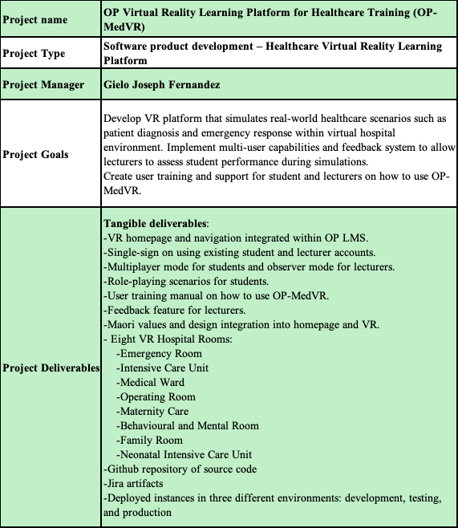

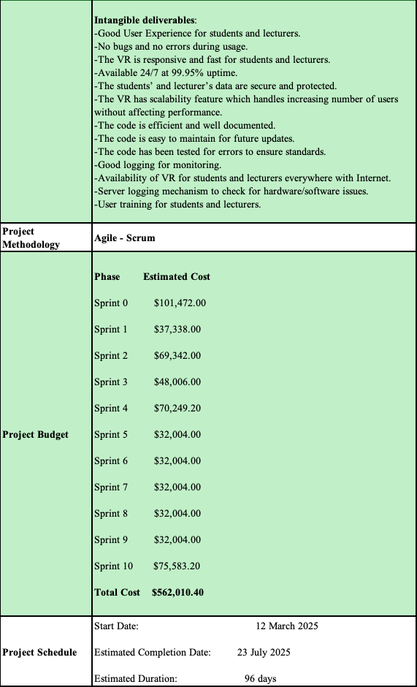

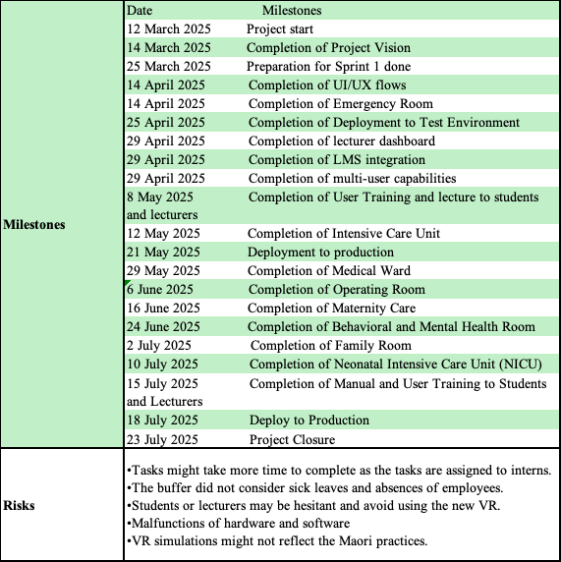

2. Background and Purpose

Otago Polytechnic is set to launch a Virtual Reality (VR) Learning Platform tailored specifically for its Nursing and Healthcare programs in Dunedin. This innovative tool will allow students to hone essential medical skills, such as diagnosing patients and managing emergencies, within a highly immersive virtual hospital setting. By replicating real-world scenarios, the VR platform will create a secure and supportive environment for students to build and perfect their clinical abilities, free from the stress or potential risks of hands-on practice in actual healthcare settings. This initiative reflects the institution’s dedication to preparing students for the challenges of modern healthcare through forward-thinking solutions.
Key features of this platform will be the eight different hospital rooms (Emergency Room, Intensive Care Unit, Medical Ward, Operating Room, Maternity Care, Behavioural and Mental Room, Family Room, and Neonatal Intensive Care Unit) that will be created in the VR world. Another key feature includes the ability for students to interact and collaborate with each other in real time. Multi-user capabilities will enable role-playing exercises that closely mimic real healthcare scenarios, helping students develop teamwork, decision-making, and communication skills. This immersive, hands-on approach will better prepare students for the challenges they will encounter in their future careers. Furthermore, the platform will integrate smoothly with the Polytechnic’s existing Learning Management System (LMS), allowing both students and lecturers to easily track progress and manage coursework
The platform will also be designed to be culturally inclusive, integrating Māori health frameworks and practices into the VR simulations. This ensures that students not only learn the technical aspects of healthcare but also gain an understanding of the cultural sensitivities necessary for delivering holistic care. The system will include realistic 3D environments and provide a built-in feedback system, enabling lecturers to evaluate student performance and offer real-time guidance.
To ensure success, the project will also involve comprehensive training programs for both students and faculty, ensuring they feel confident in using the VR technology. With a budget of NZD 564,845.40 and a planned completion timeline of 5 months, this initiative promises to be a groundbreaking step in modern healthcare education. A detailed risk management plan will tackle potential challenges, such as technology issues and resistance to new methods of learning, ensuring the platform’s long-term success and impact.

3. Project Scope

The project scope is defined as a statement by writing the context, main inputs and outputs and main functions of the system to be developed. Project scope defines all tasks, activities, resources, timelines, decisions, and project boundaries that must be done to meet project goals and deliverables. The project scope statement (PSS) is prepared for the customer to illustrate the purpose of developing the project and plan of all activities needed to accomplish the project. The PSS warrants that all stakeholders are benefited to understand the project (Althiyabi & Qureshi, 2021).

3.1. Objectives
Project objectives define the critical steps that must be taken to successfully execute a project plan. Project objectives can be tangible deliverables or intangible milestones, but they should always be SMART (specific, measurable, achievable, realistic and timebound) and related to your broader project goals. Project objectives allow you to communicate with your team and outline what individuals are responsible for what objectives to better meet stakeholder quality expectations. Your objectives should contain metrics such as budget, quality and how long it takes to finish the project (Bridges, 2024).

3.2. Deliverables
Project deliverables are essential to ensure the success of data integration projects by providing a way to measure progress and manage expectations. Well-defined deliverables help maintain sanity by setting clear expectations and preventing stakeholders from constantly asking for more than what can be realistically delivered within the allotted time. Project deliverables act as a roadmap and a control mechanism for the integration project. They help to solidify base requirements and mappings, which in turn provides the team with more flexibility to handle last-minute requests. They also communicate what features and outcomes to expect from the project from its initiation to completion (Goldfedder, 2020).
There are two types of deliverables, tangible and intangible. Tangible deliverables are physical or measurable outputs, such as a product, prototype, or a piece of software. Tangible deliverables are concrete and can be assessed for quality and completion. While intangible deliverables involve non-physical outputs like intellectual property, ideas, or knowledge transfer. Examples include business strategies, patents, or project documentation (Kharlantseva, 2025).
Regarding OP-MedVR, the table below contains the tangible deliverables.
Table 1 Tangible Deliverables
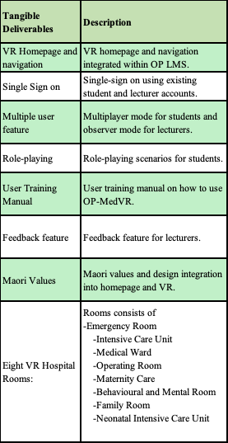

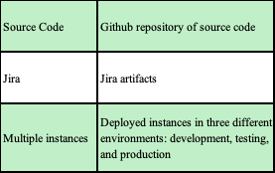
Regarding the intangible deliverables, the table below explains it more in detail.
Table 2 Intangible Deliverables
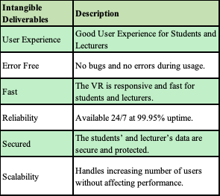

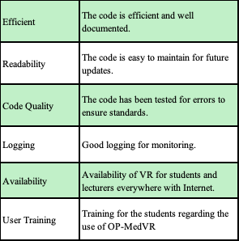

3.3. Milestones
In project management, milestones are defined as significant points or events within a project's timeline. Milestones serve as crucial reference points for tracking progress and assessing achievements against the project plan. Milestones can signify the completion of specific phases or the delivery of key deliverables. Milestones are used as benchmarks to measure how the project is advancing. By identifying when milestones are reached (or not reached), project managers can gauge whether the project is on track (Lock, 2017).
The table below discuss the project milestones of OP-MedVR in more detail.
Table 3 Project Milestones
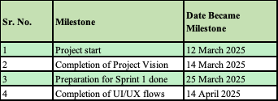
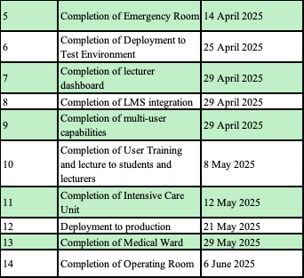
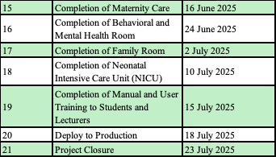

3.4. Technical requirements
In project management, are the factors required to deliver a desired function or behaviour from a system to satisfy a user’s standards and needs. Usually written in a technical requirement document, technical requirement document empowers the team to come to a mutual understanding of what is required, technically, to make your project or product a success. Technical requirements also provide information that will help you determine the needed budget, leverage work breakdown schedule, help create a realistic Gantt chart, and risk management aspects (Espinheira, 2021).
Technical requirements is broken down into two parts, functional and non-functional requirements. Functional and non-functional requirements will be discussed in detail below.

3.4.1 Functional requirements
In software development, functional requirements refer to the features and functions a solution must have to ensure it behaves as expected. In other words, proper functional requirements describe how the product enables users to complete their tasks (Rebrova, 2024). Functional requirements are simply a way to understand what to build so that you don't waste time and money building the wrong thing. It also gives you the necessary up front information to devise an elegant design that implements these requirements (Fowler, 2010).
In the case of OP-MedVR, the table below shows the functional requirements in more detail.
Table 4 Functional Requirements
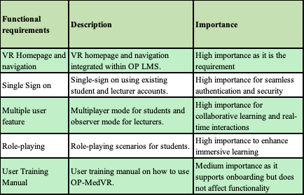

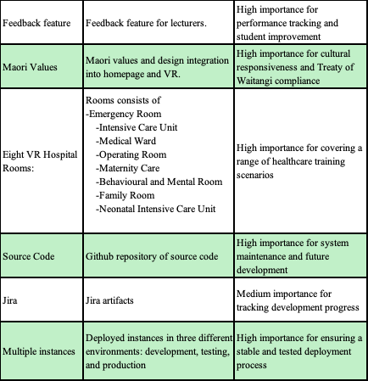

3.4.2 Non-functional requirement
In project planning, although aspects such as performance, security, usability, reliability, and scalability are not part of the functional requirements in developing a software project, it is still important as not including it may not meet user or stakeholder expectations, or the needs of the business.
In the case of OP-MedVR, the table below contains the non-functional requirements in more detail.
Table 5 Non-Functional Requirements
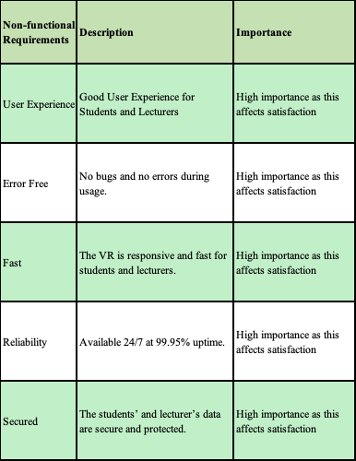

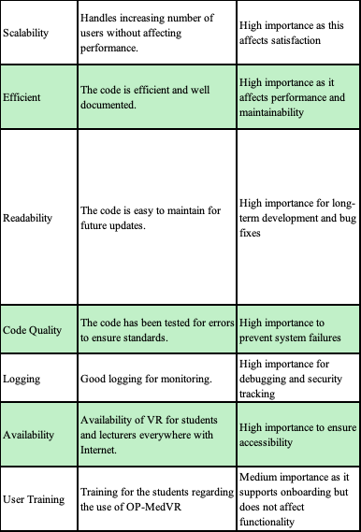

3.5. Project Exclusions
In project planning, it is necessary to include things that are not included in the project as this can lead to scope creep during the development of OP-MedVR. Similar to project limitations but project exclusion specifies any work or activities explicitly not included in the project scope. This helps manage expectations and avoid misunderstandings about project deliverables (Wootton, 2024).
In the case of OP-MedVR, the table below discusses the project exclusions in more detail.
Table 6 Project Exclusion
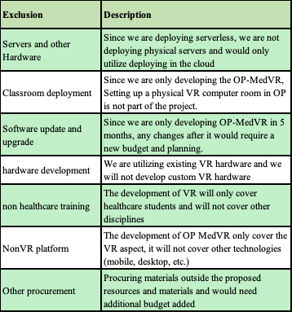

3.6. Project Limitations
In project planning, it is always important to take into account the limitations of the resources that you have. These limitations can be budget, time, technology, material choice and so on. These things are the limit of what can be done with the project. Often times these limitations guide the project, like how time can affect the quality of the delivery (Erro, 2016).
In the case of OP-MedVR, the table below discusses the project limitations in more detail.
Table 7 Project Limitation
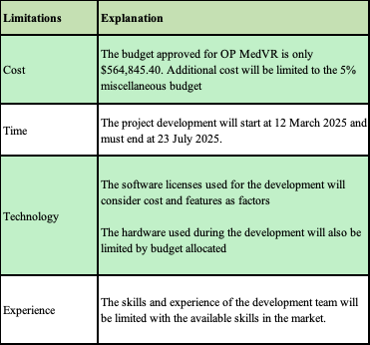

4. Project Assumptions

In project management, assumptions are factors believed to be true or real, even without any real evidence. These assumptions vary from each phase of the project lifecycle. A project manager has to make certain assumptions related to the market, resources, technology, scope, or some other project factors. If they do not, it is hard to proceed ahead because there is simply no way to give proof or certainty for everything in a project plan (Sharma, 2024).
Regarding OP-MedVR, the table below are the assumptions in this project.
Table 8 Project Assumptions
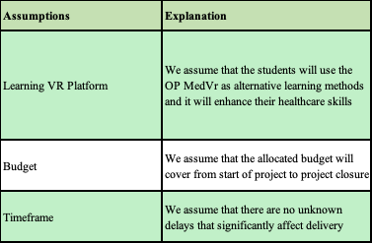

5. Methodology
Scrum is an agile approach to software development that focuses on working in small, manageable chunks. It's a way of developing products that’s flexible and collaborative, allowing teams to adapt quickly as they go. Scrum challenges the traditional, step-by-step methods of product development by emphasizing self-organizing teams. The idea is that when team members collaborate closely, both online and face-to-face, it leads to better outcomes. Instead of working in isolation, everyone on the team contributes and communicates, helping the project move forward more smoothly and flexibly. (Sachdeva, 2016).
In regard to OP-MedVR, Scrum is a good methodology because it can handle changing requirements such as lecturer/students feedback, new curriculum. Since Scrum also encourages iterative deployment, lecturer and students can quickly review OP-MedVR and provide feedback and changes earlier in the development phase. Since many hospital rooms are being developed in this project, feedback from the first room(emergency room), can be implemented in the other hospital rooms.

5.1 Justification

Below are the justifications for why Scrum is the best fit for this initiative.
Firstly, Scrum’s iterative development process allows for continuous improvement and adaptation. The OPAIC VR platform project involves cutting-edge technology and requires frequent testing and refinement to ensure it meets the needs of students and lecturers, only scrum ideal to use in this type of project scenario. By breaking the project into smaller, manageable sprints, the development team can deliver incremental updates, gather feedback, and make necessary adjustments. This is particularly important for ensuring the platform’s immersive 3D environments, multi-user capabilities, and integrated feedback system function seamlessly (Schwaber & Sutherland, 2020).
Second, Scrum emphasizes collaboration and communication, which is critical for a project involving multiple stakeholders such as OPAIC VR platform project, stakeholders in this project will include among other students, lecturers, software developers, and healthcare professionals. The daily stand-ups, sprint reviews, and retrospectives will foster transparency and ensure that everyone is aligned with the project’s goals. This collaborative approach is essential for integrating culturally responsive healthcare practices rooted in Iwi/Māori health frameworks, as it requires ongoing dialogue and input from diverse stakeholders (Rubin, 2012).
Thirdly, scrum is adopted because of Scrum’s flexibility that makes it ideal for addressing the uncertainties and challenges inherent in developing a VR platform. For instance, the risk management plan for technology malfunctions and user resistance can be continuously updated based on real-time feedback and testing. This adaptability ensures that potential issues are identified and resolved early, minimizing disruptions to the project (Sutherland & Sutherland, 2014).
Lastly, Scrum’s focus on delivering value incrementally ensures that the platform’s key features, such as role-playing for multiple participants and integration with the existing LMS, are prioritized and developed efficiently. This approach also allows for early user training, ensuring that students and lecturers become confident with the VR technology as it evolves (Mike, 2010).
In conclusion, Scrum’s iterative, collaborative, and flexible framework makes it the most suitable methodology for the VR Learning Platform project. It enables continuous improvement, fosters stakeholder collaboration, and ensures the timely delivery of high-quality, culturally inclusive healthcare training solutions.

5.2 Māori Value: how you can apply Māori values
Implementing Māori values such as Whanaungatanga and Kaitiakitanga is necessary as it is needed to comply with NZQA and Māori Council standards. The team also hired a Cultural Consultant to help with implementing Māori Values. To implement Whanaungatanga and Kaitiakitanga, it is done in the following ways below:
Table 9 Maori Values for OP-MedVR
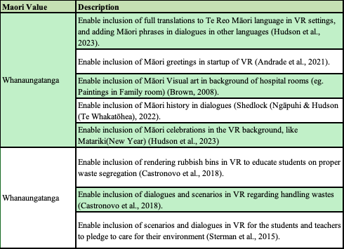
Adopting Māori ideals like Manaakitanga, and Whanaungatanga should be implemented in the OPAIC IT project in several ways. For Manaakitanga, by actively encouraging open communication, empathy, and inclusivity, the project team can ensure that every member feels valued and accepted. This may include planning frequent team-building exercises and encouraging a spirit of belonging among team members.

6. Project Risks and Risk Management Plan
In project management, project risk is defined as the chance of certain occurrences adversely affecting project objectives. It is the degree of exposure to negative events, and their probable consequences. Project risk is therefore characterized by the following risk factors: risk event, risk probability, and amount at stake. Therefore risk management, is the art and science of identifying, analyzing and responding to risk factors throughout the life of a project and in the best interests of its objectives (Pym, 1987). The steps in risk management process are the following: risk identification, risk assessment, risk treatment, risk response planning, risk monitoring and control and risk communication (Martins, 2024).
The table below contains the risk assessment matrix.
Table 10 Risk Assessment Matrix
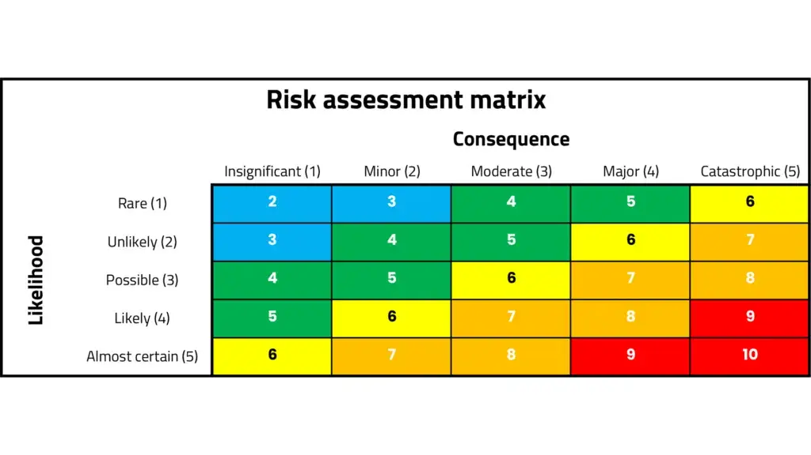
In the case of OP-MedVR. The table below shows the risks, probability of risk occurring, impact on the project delivery, risk level, member responsible for risk prevention, and mitigation steps.
Table 11 Project Risks and Risk Management Plan
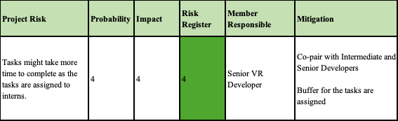

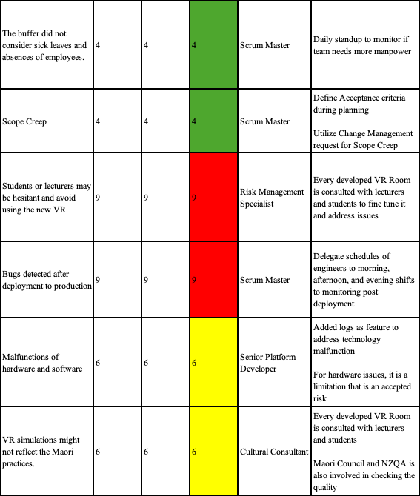

7. Project Organisation

A project organizational structure is used to determine the hierarchy and authority of people involved in a specific project. The structure defines each team member’s function and the reporting lines on a chart for team members to reference during a project. Project managers use project organization to align team members before and during a project. The process minimizes disruption to your workflow and conflict among team members, as well as leads to maximum productivity among team members involved in a project (Martins, 2024).
For the OP-MedVR, There is no Scrum Master role since the plan is to have the whole development team rotate on the Scrum Master role except the Project Manager and the Product Owner (Shuiqing Yu, 2019). The whole development team reports to the Senior Product Owner and the Senior Product Owner and the HR Manager reports to the Project Manager. The student and lecturer assigned by OP reports to the OP.
The table below shows the project organisation structure, their roles, responsibilities, and who they report to.
Table 12 Project Organisation
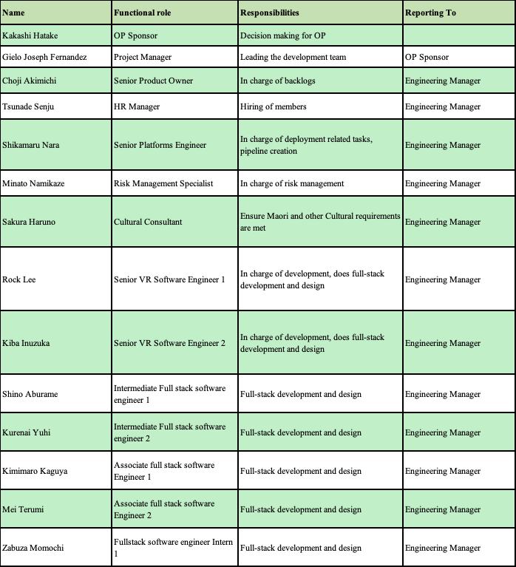
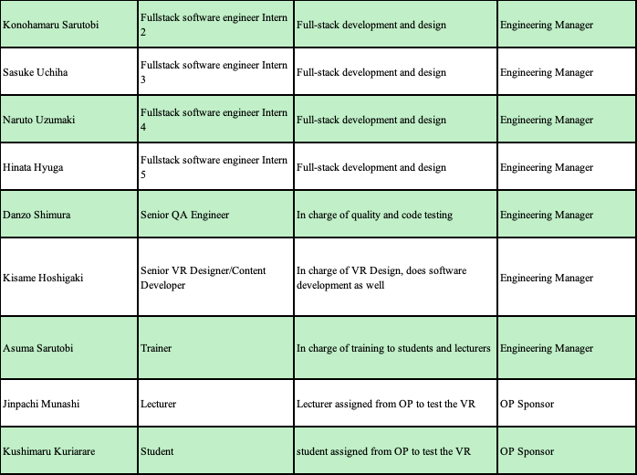

8. Communications with Stakeholders

8.1 Stakeholders identification.
A stakeholder is a person, group or organization with a vested interest, or stake, in the decision-making and activities of a business, organization or project. Stakeholders can be members of the organization they have a stake in, or they can have no official affiliation. Stakeholders can have a direct or indirect influence on the activities or projects of an organization. Their support is often required for business and project success (Barney, 2023).
In the case of OP-MedVR, the stakeholders will be the following:
Table 13 Stakeholder Identification
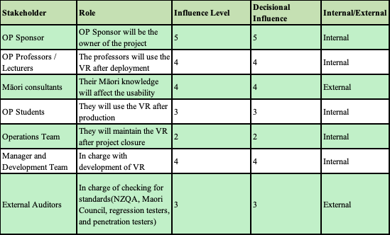

8.2 Communication plan
Agile ceremonies are composed of daily standup, story grooming, sprint planning, sprint review, and sprint retrospective which are used to discuss the project’s next course of action (Laoyan, 2025).
In the case of OP-MedVR, communication with stakeholders will be done during these agile ceremonies. It will be discussed in detail below.
Table 14 Communication Plan
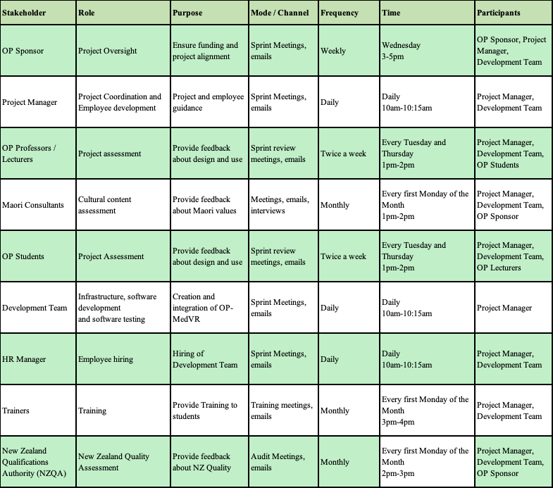

9. Change management plan
Change management ensures that a project achieves its intended results and outcomes by supporting the individual transitions required by that project. When a new technology is used, employees must adopt and use it to deliver value. When you implement a new process, employees must adopt and use it to deliver value. Project-level change management provides the specific strategies, plans, actions and steps that focus on impacted employees and work in alignment with a project deployment (Creasey, 2022).
In scrum, changing requirements is quite common. Agile Manifesto Principle says “Welcome changing requirements, even late in development. “(Beck et al., 2001). Which means, we take decisions on what to do by seeing what results we are seeing. This approach will involve changing requirements as we go along (Kulkarni, 2023). The following below are done in the scenario of a change request (Dworniczak, 2025):
The figure below contains the sample change control procedure.
Figure 2 Change Control process
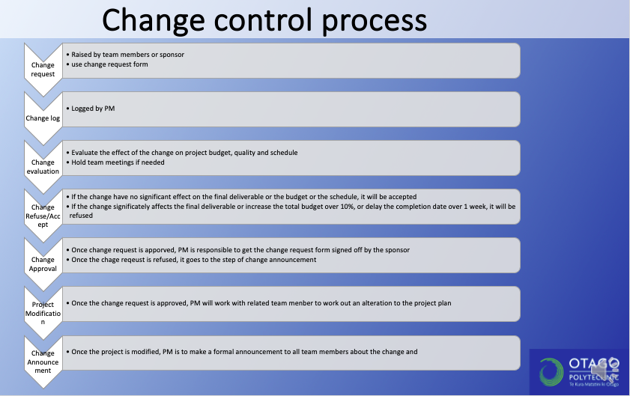
In the case of OP-MedVR, the following is done to assess change request:
- The change request form goes to the Product Owner and the stakeholders. Product owner and the stakeholders checks for cost-benefit effect, risk assessment, resource availability, impact on scope, and priority.
- Once it is approved, the Product Owner discusses with the scrum master and the development team regarding the effect of the change request. For example, the ICU room VR might get delayed in delivery if we apply this change. The development team discusses possible scenarios on how change request will be delivered.
- The Product Owner relays it to the stakeholders the scenarios to see if they will agree to it. The Product Owner then adjusts then backlog based on it.
- The change request then gets implemented based on the priority in the backlog.

Regarding the change request form, the form below is a template that can be used.
Figure 3 Change Request Form (Project Management Docs, 2023)
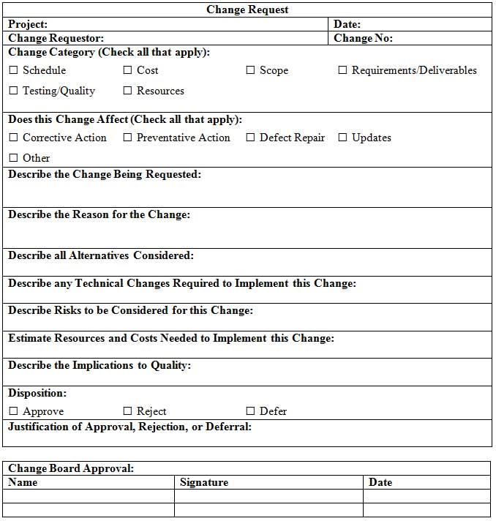

10. Project Estimation Technique
A successful project starts with a successful estimate. To properly schedule the work to execute your project, you need to know the timeline, costs, scope, risk and more. All of these considerations are part of project estimation techniques. Estimation techniques help make decisions on the viability of your project. If you decide to move forward, they’re essential to forecasting projects accurately (Hennesy, 2022). The following below are some of the estimation methods:
1. Analogous estimation: A technique for estimating costs for your current projects and future projects based on a similar past project. Analogous estimating is one of the most detailed and accurate ways to estimate the cost data for a given project, so that you can set up an accurate cost baseline, without entering into the world of statistical models (Viter, 2022).
2. Parametric estimation: A statistical and accuracy-based technique for calculating the time, cost, and resources needed for project success. Combining historical and statistical data, parametric estimating uses the relationship between variables to deliver accurate estimations. Often used during a project or in the project planning phase, parametric estimating applies a formula or algorithm for making these calculations, using the specific cost or time needed to implement and finish a project or task (Udoagwu, 2022).
3. PERT diagram: A graphical illustration of a project as a network diagram consisting of numbered nodes linked by labelled vectors. PERT charts help project managers estimate the minimum time needed to complete a project. Managers can also analyse the work breakdown and task connections and assess project risks. The breakdown structure makes it easy to organize a complex project with a variety of moving parts by visualizing the dependencies between each step of the process (Sheldon et al., 2024).
4. Top-down approach: Frequently used for creating rough order of magnitude (ballpark) estimates at an early stage of the project, when the level of detail available is limited (they can also be used for validation purposes). Top-down estimates generally take less time and effort to produce than bottom-up estimates. The main benefit of top-down is the chance to use more holistic data from previous projects or products, including unmitigated and unforeseen risks, and scope creep. This can help reduce the risk of overlooked work activities or costs (Rowland, 2019).
5. Bottom-up approach: It is when you build your estimates from the most granular level of work needed in a specific project and estimate “up” from there to the bigger picture of the project. The superpower of this estimation technique lies in its unparalleled specificity. This creates a work breakdown structure (WBS) to estimate all the details of the lowest level of work needed and then add them up as you work up to the larger activities of a project. You can get to the discrete details by breaking the project into smaller deliverables and then individual tasks (Card, 2024).
6. Three-point estimation: a project estimation technique used to assess the likely outcomes or costs of anticipated. This approach enables project managers to generate realistic estimates and derive an expected value through a comprehensive evaluation, even with limited information. This is a powerful approach that involves analysing and incorporating multiple estimates: optimistic estimate (O), pessimistic estimate (P), and most likely estimate (M). Optimistic estimate represents the best case scenario, the pessimistic estimate represents the worst-case scenario, and the most likely estimate represents the middle ground (Davis, 2023).
In the case of OP-MedVR, Bottom-up approach and parametric estimation was used since most tasks are related, we can allocate the effort and budget for each specific task in relation to previous tasks (Guthrie, 2023). Bottom-up approach is great for this as well as we get to estimate all the activities needed by breaking it down into smaller tasks (Usifo, 2024).
11. Budget
A project budget is the total projected costs needed to complete a project over a defined period of time. It’s used to estimate what the costs of the project will be for every phase of the project. Creating a project budget is a critical part of the project planning process. The project budget will include such things as labour costs, material procurement costs and operating costs. But it’s not a static document. Your project budget will be reviewed and revived throughout the project, hopefully with the help of project budgeting software (Bridges, 2023b).
In relation to OP-MedVR, the expenses used in the preparation (sprint 0) will include all the necessary equipment and software needed for the duration of the project (5 months). The expenses in the sprints (Sprint 1 – Sprint 10) will focus on the labour costs and 5% for miscellaneous cost. This is under the assumption that licenses and equipment were already purchased during preparation, and that since all the employees are working from home, there is minimal cost in other expenses which will be covered by miscellaneous cost.
The table below contains the general budget breakdown for OP-MedVR.
Table 15 OP-MedVR Budget
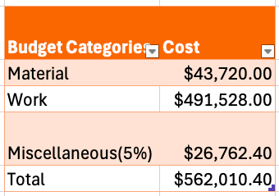
For the budget for materials, the budget allotted is for the duration of the development of OP-MedVR(5 months) and the needed equipment of the development team. The rent and electricity is $0 under the assumption that the whole team is remote/working from home status. The cost on rent and electricity will be considered under miscellaneous.
The table below contains the budget breakdown for materials.
Table 16 OP-MedVR Materials Budget
material | quantity | cost per unit | total cost | purpose | source
Keyboard | 20 pcs | $45.00 | $900.00 | For the use of employees | PowerPlay Keyboard
Mouse | 20 pcs | $20.00 | $400.00 | For the use of employees | Warehouse Mouse
Jira | 5 months | $172.00 | $860.00 | License for use of Jira | Jira
Laptops | 20 pcs | $1,300.00 | $26,000.00 | For the use of employees | Dell Laptop
VR Hardware | 20 pcs | $650.00 | $13,000.00 | For the use of employees | Meta Quest
Unreal Engine License | 0 | $0.00 | $0.00 | license for VR development | Unreal Engine
GitHub | 20 pcs x 5 months | $4.00 | $400.00 | license for GitHub repository | GitHub
Azure Subscription | 5 months | $432.00 | $2,160.00 | license for cloud use | Azure Calculator
Electricity | 0 | $0.00 | $0.00 | no electricity (remote work)
Rent | 0 | $0.00 | $0.00 | no rent (remote work)
Total |  |  | $43,720.00

The rate per hour for each employee were based on the salary sourced from Glassdoor and Seek (2025) as what employers are offering based in current market demand. The annual salary is divided by 52 weeks and then divided by 40 hours per week to get the salary per hour.
The pay rates for the team employees were estimated based on the information sourced from SEEK (2021) as the source of most recent information what the employers are ready to offer for IT specialists in current market situation. The average annual salary from ten most recent job advertisements with the pay range per occupation was divided by standard 52 working weeks per year and 40 hours per week to calculate the hourly rate.
For the Work Breakdown Structure, the Work breakdown Structure in the MS Project is not utilised under the assumption that all the employees of the team are working full time in the background(communicating with stakeholders, code reviews, testing features, bug fixes, grooming tasks, etc..) even though they are not assigned a project in MS Project, which implies that they are working 8 hours per day, and 5 days per week. This is in exception to the HR Manager and Trainer, which will only work for 5 days and 6 days respectively.
The table below contains the budget breakdown for Work/Labour.
Table 17 OP-MedVR Work Budget
Role | hours | hourly rate | total cost | source
HR Manager | 8 hours x 5 days | $53.00 | $2,120.00 | HR Manager
Project Manager | 8 hours x 96 days | $51.00 | $39,168.00 | Project Manager
Senior Platforms Engineer | 8 hours x 96 days | $52.00 | $39,936.00 | Senior Platforms Engineer
Risk Management Specialist | 8 hours x 96 days | $34.00 | $26,112.00 | Risk Management Specialist
Cultural Consultant | 8 hours x 96 days | $42.00 | $32,256.00 | Cultural Consultant
Senior Product Owner | 8 hours x 96 days | $48.00 | $36,864.00 | Senior Product Owner
Senior VR Software Engineer 1 | 8 hours x 96 days | $46.00 | $35,328.00 | Senior VR Software Engineer
Senior VR Software Engineer 2 | 8 hours x 96 days | $46.00 | $35,328.00 | Senior VR Software Engineer
Intermediate Full stack software engineer 1 | 8 hours x 96 days | $33.00 | $25,344.00 | Intermediate Full stack software engineer
Intermediate Full stack software engineer 2 | 8 hours x 96 days | $33.00 | $25,344.00 | Intermediate Full stack software engineer
Associate full stack software Engineer 1 | 8 hours x 96 days | $28.00 | $21,504.00 | Associate full stack software Engineer
Associate full stack software Engineer 2 | 8 hours x 96 days | $28.00 | $21,504.00 | Associate full stack software Engineer
Fullstack software engineer Intern 1 | 8 hours x 96 days | $25.00 | $19,200.00 | Fullstack software engineer Intern
Fullstack software engineer Intern 2 | 8 hours x 96 days | $25.00 | $19,200.00 | Fullstack software engineer Intern
Fullstack software engineer Intern 3 | 8 hours x 96 days | $25.00 | $19,200.00 | Fullstack software engineer Intern
Fullstack software engineer Intern 4 | 8 hours x 96 days | $25.00 | $19,200.00 | Fullstack software engineer Intern
Fullstack software engineer Intern 5 | 8 hours x 96 days | $25.00 | $19,200.00 | Fullstack software engineer Intern
Senior QA Engineer | 8 hours x 96 days | $34.00 | $26,112.00 | Senior QA Engineer
Senior VR Designer/Content Developer | 8 hours x 96 days | $35.00 | $26,880.00 | Senior VR Designer/Content Developer
Trainer | 8 hours x 6 days | $36.00 | $1,728.00 | Trainer
Total |  |  | $491,528.00

12. Quality Control and Audit
- Quality Control
Quality control (QC) is a process through which a business seeks to ensure that product quality is maintained or improved. QC requires the company to create an environment where management and employees strive for perfection. This is done by training personnel, creating benchmarks for product quality, and testing products to check for statistically significant variations (Hayes, 2024).
Regarding OP-MedVR, the table below contains the Audit Control done for the duration of the project.
Table 18 Quality Control for OP-MedVR
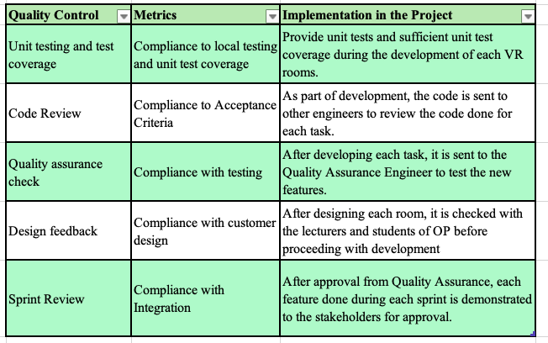
- Audit
The audit is designed to determine the status of work performed on a project to ensure it complies with the statement of work, such as the scope, time and budget of the project, along with the maturity of the project management process. During audit the project scope, schedule, quality, cost, resources, and risks are checked to make sure it is still following the project plan (Bridges, 2023a). However in agile teams, the process sometimes deviates to address certain issues, which is expected as stated in the Agile Manifesto, “Individuals and interactions over processes and tools” (Beck et al., 2001). The auditor should communicate with Product Owner and Scrum master to ensure that agile practices were followed (Nair, 2019). In OP-VR LMS, the auditor should check the artifacts created during sprint planning, review and retrospective, as well as product backlogs.
As part of preparation for deployment to production, the table below are asked with setting up the audit of OP-MedVR.
Table 19 Audit Check for OP-MedVR
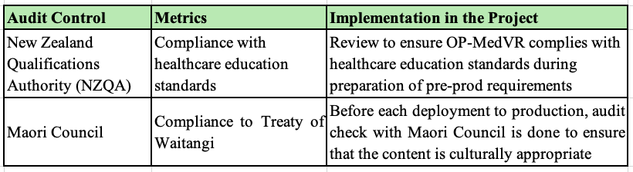

13. Project Closure
Agile project closure is a pivotal phase that ensures the project concludes smoothly while capturing valuable insights for future endeavours. Unlike traditional methodologies, Agile project closure is iterative and aligned with the Agile principles (Sengupta, 2023). To ensure the successful transfer of ownership from the Agile team to the operations team, the following items below are done to make sure we tie up any loose ends (Cosgrove & Hubbard, 2020).
In regards to OP-MedVR, the table below contains the actions done during project closure.

Table 20 Project Closure for OP-MedVR
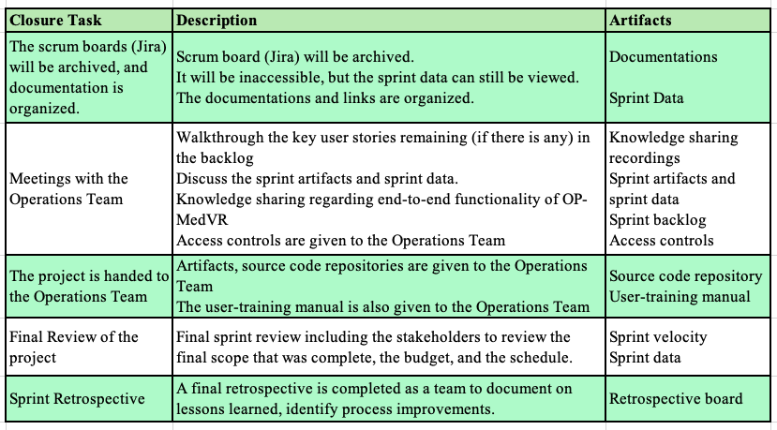

14. Appendices

HR Manager - $53 per hour
https://www.glassdoor.co.nz/job-listing/hr-manager-foster-moore-JV_IC3525162_KO0,10_KE11,23.htm?jl=1009673518619&cs=1_ec9b4ff3&s=58&t=SR&pos=102&src=GD_JOB_AD&guid=00000195b27bb2459b30eef8ec034985&jobListingId=1009673518619&ea=1&ao=1136043&vt=w&jrtk=5-pdx1-0-1imp7nckhgqnl800-1d963c8dbd503581&cb=1742456206940&ctt=1742456254121
Project Manager – 51$ per hour
https://www.glassdoor.co.nz/job-listing/ict-project-manager-techwise-solutions-JV_IC3525162_KO0,19_KE20,38.htm?jl=1009652037968&cs=1_b6da3e24&s=58&t=SR&pos=104&src=GD_JOB_AD&guid=00000195b27ff695b5f85de7264cd50c&jobListingId=1009652037968&ao=1136043&vt=w&jrtk=5-pdx1-0-1imp7vtnigoog804-582d7553ed486054&cb=1742456485931&ctt=1742456494351

Senior Platforms Engineer - $52 per hour
https://www.glassdoor.co.nz/job-listing/senior-devops-engineer-fiserv-JV_IC3525162_KO0,22_KE23,29.htm?jl=1009678594918&cs=1_74fa5c4f&s=58&t=SR&pos=102&src=GD_JOB_AD&guid=00000195b28109a394510563b18d3c45&jobListingId=1009678594918&ao=1136043&vt=w&jrtk=5-pdx1-0-1imp822fq2afp000-bb82b31d9c399180&cb=1742456556303&ctt=1742456627109

Risk Management Specialist – $34 per hour
https://www.glassdoor.co.nz/job-listing/product-development-specialist-hub-services-iag-new-zealand-JV_IC3525162_KO0,43_KE44,59.htm?jl=1009662255445&cs=1_4ef51041&s=58&t=SR&pos=102&src=GD_JOB_AD&guid=00000195b283066fa760d46250f5cb8e&jobListingId=1009662255445&ao=1136043&vt=w&jrtk=5-pdx1-0-1imp861lui0ht800-3a847457d00276f3&cb=1742456686571&ctt=1742456707752

Cultural Consultant - $42 per hour
https://www.glassdoor.co.nz/job-listing/work-winning-consultant-aurecon-group-JV_IC3525162_KO0,23_KE24,37.htm?jl=1009561005629&cs=1_448e59b4&s=58&t=SR&pos=101&src=GD_JOB_AD&guid=00000195b285d69893ad4e1c0af95b38&jobListingId=1009561005629&ao=1136043&vt=w&jrtk=5-pdx1-0-1imp8blnd222o000-75b1809a532fc97c&cb=1742456870868&ctt=1742456884958

Senior Product Owner - $48 per hour
https://www.glassdoor.co.nz/job-listing/product-owner-data-ai-products-asurequality-JV_IC3525162_KO0,30_KE31,43.htm?jl=1009672349495&cs=1_08ef0467&s=58&t=SR&pos=104&src=GD_JOB_AD&guid=00000195b28b54b9befd8a203fdf0cc2&jobListingId=1009672349495&ea=1&ao=1136043&vt=w&jrtk=5-pdx1-0-1imp8ml8ajdr1800-79507115f3c44640&cb=1742457230884&ctt=1742457239278

Senior VR Developer - $46 per hour
https://www.seek.co.nz/job/82471580?type=promoted&ref=search-standalone&origin=cardTitle#sol=077b2a7917309a47ff35c3d0496275e95285e244

Intermediate Full Stack Software Engineer - $33 per hour
https://www.seek.co.nz/job/82758697?type=standard&ref=search-standalone&origin=cardTitle#sol=1f6ec098bbebe4ded5ecba67a912927d61441054

Associate Full Stack Software Engineer – $28 per hour
https://www.glassdoor.co.nz/Salary/Aderant-Associate-Software-Engineer-Salaries-E37370_D_KO8,35.htm

Senior QA Engineer - $34 per hour
https://www.glassdoor.co.nz/job-listing/senior-qa-engineer-payment-product-binance-JV_IC3525162_KO0,34_KE35,42.htm?jl=1009335940342&src=GD_JOB_AD&uido=65FC4472BDEC32AAD12883C19DB458B2&ao=1136043&jrtk=5-pdx1-0-1impacp24gqnl800-2c32325891c848b1&cs=1_12244bb7&s=58&t=SR&pos=102&guid=00000195b2a663e695acf38a3d7b45b8&jobListingId=1009335940342&ea=1&vt=w&cb=1742459004143&ctt=1742459011545

Senior VR Designer/Content Developer - $35 per hour
https://www.glassdoor.co.nz/job-listing/game-director-lead-game-designer-tencent-JV_IC3525162_KO0,32_KE33,40.htm?jl=1009649781596&cs=1_3e9eaa24&s=343&t=SR-JOBS-HR&pos=102&src=GD_JOB_AD&guid=00000195b2a948ee89ebfea76a296686&uido=65FC4472BDEC32AAD12883C19DB458B2&jobListingId=1009649781596&ao=1136043&vt=w&jrtk=5-pdx1-0-1impaij15gqmt800-af997ef44ac85d47&cb=1742459194620&ctt=1742459202771

Trainer - $36 per hour
https://www.seek.co.nz/job/82815772?type=standard&ref=search-standalone&origin=cardTitle#sol=84016d139461aca38e6d722bb3f7f84abd331b3e
Developer Intern - $25 per hour
https://www.sjs.co.nz/job-details/21526/mechatronics-rnd-engineer-intern-casualpartfull-time-cbd/

Laptops - $1300 x 20 = $26000
https://www.dell.com/en-nz/shop/dell-laptops/inspiron-15-laptop/spd/inspiron-15-3520-laptop/oin3520100901mnzh?ref=variantstack

Keyboard - $45 x 20 = 900
https://www.pbtech.co.nz/product/KEYEBL1026/PowerPlay-E-Blue-Mechanical-Sense-RGB-Gaming-Keybo?srsltid=AfmBOooLZOmmTw6reVHHwSRwjH_6l9iixH98waNnHECwnCvt0Ds56fdIxjI&gStoreCode=PBAucklandCBD

Mouse - $20 x 20 = $400
https://www.thewarehouse.co.nz/p/logitech-m190-full-size-wireless-mouse---blue-910-005914/M18529702.html?srsltid=AfmBOortW7da92oV1ogJUmJ3HhpLUx3YZDpAapauHqF3Qt9arrRaK8aDHzI

VR hardware - $650 x 12 = $7800
https://www.pbtech.co.nz/product/MVRMTA0024/META-Quest-3s-128GB-Mixed-Reality-Headset-with-2x?qr=GShopping&gad_source=1&gclid=Cj0KCQjw-e6-BhDmARIsAOxxlxVaWUoXJIuyEoiQJ3eRXoX368WtnsJzZHLHL6e3mIZI5g8FZ-UVGZwaAntYEALw_wcB

Azure Subscription - $432 per month
https://azure.microsoft.com/en-us/pricing/calculator/?ef_id=_k_Cj0KCQjw-e6-BhDmARIsAOxxlxX14GT6Xgk_PIpmy9nZve2RbTFsrkhuQPFPnsWSuwNOKvzvVE6FhBAaAhw8EALw_wcB_k_&OCID=AIDcmmp3m06wb2_SEM__k_Cj0KCQjw-e6-BhDmARIsAOxxlxX14GT6Xgk_PIpmy9nZve2RbTFsrkhuQPFPnsWSuwNOKvzvVE6FhBAaAhw8EALw_wcB_k_&gad_source=1&gclid=Cj0KCQjw-e6-BhDmARIsAOxxlxX14GT6Xgk_PIpmy9nZve2RbTFsrkhuQPFPnsWSuwNOKvzvVE6FhBAaAhw8EALw_wcB
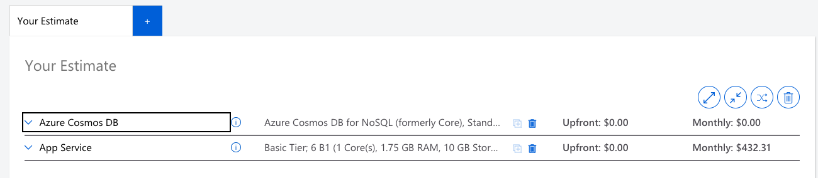

VR Software Licenses - free
https://www.unrealengine.com/en-US/license
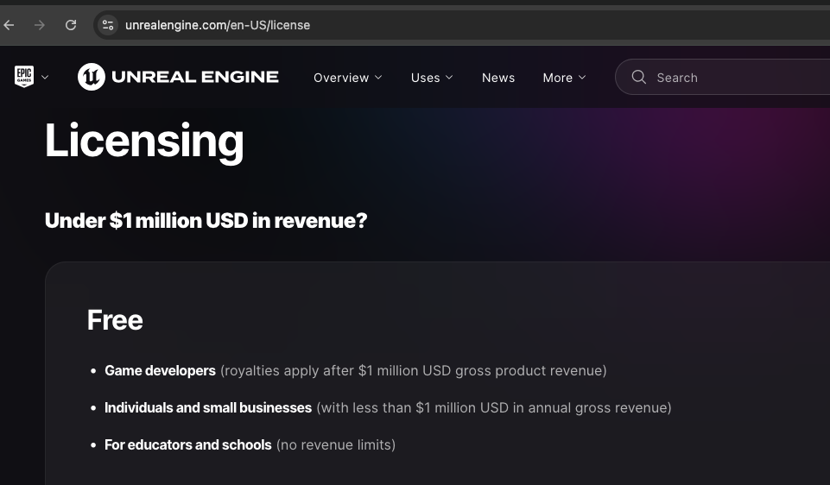

Github - $4 x 20 = $80 per month
https://github.com/pricing
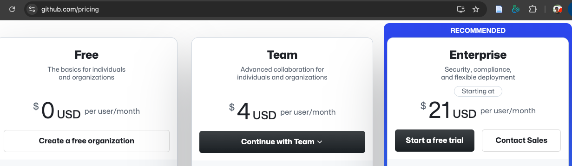

Jira - $8.6 x 20 = $172 per month
https://www.atlassian.com/software/jira/pricing
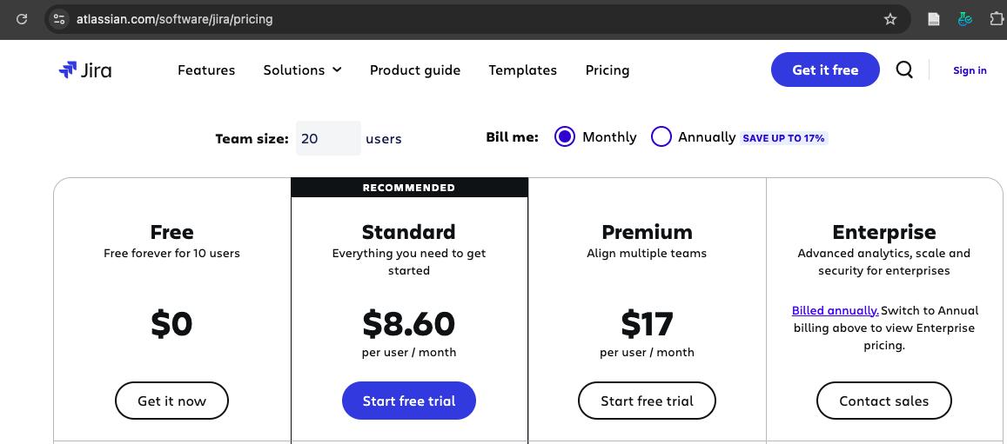

15. References:
Althiyabi, T., & Qureshi, R. (2021). Predefined project scope changes and its causes for project success. International Journal of Software Engineering & Applications (IJSEA), 12(2/3).
Andrade, A. D., Techatassanasoontorn, A. A., Singh, H., & Staniland, N. (2021). Indigenous cultural re-presentation and re-affirmation: The case of M_aori IT professionals. Information Systems Journal. https://doi.org/doi:10.1111/isj.12331
Barney, N. (2023). Stakeholder. TechTarget. https://www.techtarget.com/searchcio/definition/stakeholder
Beck, K., Cohn, M., Jeffries, R., Anderson, D., Beedle, M., Boehm, B., Combemale, B., Highsmith, J., Hunt, A., Kern, P., Larman, C., Martin, R., Mellor, S., Schwaber, K., Sutherland, J., & Thomas, D. (2001). The Agile Manifesto. Agile Alliance. http://agilemanifesto.org/
Bridges, J. (2023a). How to Do a Project Audit: A Quick Guide. ProjectManager.Com. https://www.projectmanager.com/training/project-management-audit
Bridges, J. (2023b). How to Make a Project Budget: Project Budgeting Basics (Templates Included). ProjectManager.Com. https://www.projectmanager.com/training/create-and-manage-project-budget
Bridges, J. (2024). How to Write Effective Project Objectives & Goals Every Time. https://www.projectmanager.com/training/how-to-write-effective-project-objectives-every-time
Brown, D. (2008). “Ko to ringa ki nga rakau a te Pakeha”—Virtual Taonga Maori and Museums. Visual Resources, 24(1), 59–75. https://doi.org/10.1080/01973760801892266
Card, K. (2024). Accurate Project Estimations: A Deep Dive Into Bottom-up Estimation. UseMotion.Com. https://www.usemotion.com/blog/bottom-up-estimating
Castronovo, F., Yilmaz, S., Rao, A., Condori, W., & Monga, K. (2018). Development of a Virtual Reality Educational Game for Waste Management: Attack of the Recyclops. 24–27.
Cosgrove, E., & Hubbard, K. (2020). Agile closing out project. Action Engineering Blog. https://www.action-engineering.com/blog/agile-closing-out-project/
Creasey, T. (2022). Change Management at the Project Level. Prosci. https://www.prosci.com/blog/change-management-at-the-project-level
Davis, K. (2023). Three-Point Estimating: Definition, Formula, Example. KnowledgeHut Blog. https://www.knowledgehut.com/blog/project-management/three-point-estimating
Dworniczak, M. (2025). Understanding Change Requests in Scrum. LinkedIn. https://www.linkedin.com/pulse/understanding-change-requests-scrum-mariusz-mario-dworniczak-pmp-i26bf
Eby, K. (2021). Essential Guide to Project Organizational Structure. https://www.smartsheet.com/content/project-management-organization?srsltid=AfmBOoo1noRBtZhQ4hZJVw7TRajpVMRSrta9YgIbSvq2FbhXB16auQu4
Erro, S. (2016). Limitations vs. Constraints. https://medium.com/@SteveErro/limitations-vs-constraints-575d9334ed2f
Espinheira, E. (2021). Management Fix. ILLUMINATION. https://medium.com/illumination/management-fix-9a4ce364ced2
Fowler, K. (2010). Chapter 1—Best Practices in Mission-Assured, Mission-Critical, and Safety-Critical Systems. In K. Fowler (Ed.), Mission-Critical and Safety-Critical Systems Handbook (pp. 1–82). Newnes. https://doi.org/10.1016/B978-0-7506-8567-2.00001-9
Goldfedder, J. (2020). Finding Your Purpose: Project Deliverables. In J. Goldfedder (Ed.), Building a Data Integration Team: Skills, Requirements, and Solutions for Designing Integrations (pp. 49–73). Apress. https://doi.org/10.1007/978-1-4842-5653-4_4
Guthrie, G. (2023). How to use parametric estimating to improve project performance. Nulab. https://nulab.com/learn/project-management/how-to-use-parametric-estimating-to-improve-project-performance/
Hayes, A. (2024). Quality Control: What It Is, How It Works, and QC Careers. Investopedia. https://www.investopedia.com/terms/q/quality-control.asp
Hennesy, M. (2022). Project Estimation Techniques. ProjectManager.Com. https://www.projectmanager.com/blog/project-estimation-techniques
Hudson, P., Whaanga, H., & Keegan, T. T. (2023). Computing Technologies for Resilience, Sustainability, and Resistance. IEEE Ann. Hist. Comput., 45(4), 27–38. https://doi.org/10.1109/MAHC.2023.3325249
Kharlantseva, M. (2025). What Is a Deliverable? Understanding Project Outputs and Expectations. Everhour Blog. https://everhour.com/blog/what-is-a-deliverable/
Kulkarni, S. (2023). Change Management in Scrum. World of Agile. https://worldofagile.com/blog/change-management-in-scrum/
Laoyan, S. (2025). Understanding the 4 Agile ceremonies. Asana. https://asana.com/resources/agile-scrum-ceremonies
Lock, D. (2017). The Essentials of Project Management (4th, Ed.). Routledge.
Martins, J. (2024). Step-by-step guide to the risk management process. https://asana.com/resources/project-risk-management-process
Nair, B. (2019). Auditing Agile Projects & Agile Auditing- A primer. LinkedIn. https://www.linkedin.com/pulse/auditing-agile-projects-auditing-primer-biju-nair
Project Management Docs. (2023). Change Request Template. Project Management Docs. https://www.projectmanagementdocs.com/template/project-documents/change-request/#google_vignette
Pym, D. V. (1987). Risk Management. PM Network, 1(3), 33–36.
Rebrova, A. (2024). Functional vs Non-Functional Requirements in Software Development. Mad Devs Blog. https://maddevs.io/blog/functional-vs-non-functional-requirements/
Rowland, M. (2019). Three ways to approach cost estimation. APM.Org.Uk. https://www.apm.org.uk/blog/three-ways-to-approach-cost-estimation/
Sengupta, S. (2023). Project closure strategy for agile project. Medium. https://medium.com/@mailme.senguptasudipta/project-closure-strategy-for-agile-project-0744c8440a86
Sharma, N. (2024). Project assumptions: Guide to identify, evaluate & manage risks. ProofHub. https://www.proofhub.com/articles/project-assumptions
Shedlock (Ngāpuhi, N. P., Te Whakatōhea) ,Kevin, & Hudson (Te Whakatōhea), P. (2022). Kaupapa Māori concept modelling for the creation of Māori IT Artefacts. Journal of the Royal Society of New Zealand, 52(sup1), 18–32. https://doi.org/10.1080/03036758.2022.2070223
Sheldon, R., Chai, W., & Brush, K. (2024). What is a PERT chart? And how to use it, with examples. TechTarget. https://www.techtarget.com/searchsoftwarequality/definition/PERT-chart
Shuiqing Yu, J. (2019). Five Benefits of a Rotating Scrum Master. https://www.linkedin.com/pulse/five-benefits-rotating-scrum-master-shuiqing-yu-joseph/
Sterman, J., Franck, T., Fiddaman, T., Jones, A., McCauley, S., Rice, P., Sawin, E., Siegel, L., & Rooney-Varga, J. N. (2015). WORLD CLIMATE: A Role-Play Simulation of Climate Negotiations. Simulation & Gaming, 46(3–4), 348–382. https://doi.org/10.1177/1046878113514935
Udoagwu, K. (2022). The Ultimate Guide to Parametric Estimating in Project Management. Wrike.Com. https://www.wrike.com/blog/guide-to-parametric-estimating-in-project-management/
Usifo, D. (2024). How to Use Bottom-Up Estimating in Project Management. DeeProjectManager.Com. https://deeprojectmanager.com/bottom-up-estimating-project-management/
Viter, I. (2022). Understanding the Analogous Estimating Technique. Runn.Io. https://www.runn.io/blog/analogous-estimating
Wootton, P. (2024). Project Scope Statement. https://www.projectmanagement.com/wikis/961606/project-scope-statement#_=_

